Sensor Project

# Weekly Report 2

# Chen Siwei

## **Current Topic**

Indoor position/movement tracking with IMU.

## **Project Information:**

Controller: Seeduino Main board v1.1

Sensor: Xadow 9150 IMU

IMU is an inertial measurement unit. Basically, Xadow 9150 IMU is a 9 degrees of freedom (9dof) IMU. It provides 3 rates of angle change from Gyroscope, 3 accelerations from accelerometer and 3 values from magnetometer. By using those values we may be able to find the world linear acceleration and hence find the world linear position.

## **What have been done within the week?**

1. Found a solution to main problem that the object will be pulled slowly towards the original point mentioned in the last report.

The answer is to reset the velocity when all directions of acceleration is almost 0. However, it is not correct to simply assign zeros to velocity when acceleration approach zero as it will bring in low frequency drifts. Therefore, I assign high frequency but low value to velocities. It means the stationary velocity is a series like 0.001, -0.001, 0.001, -0.001 and so on.

This is how the result looks like:

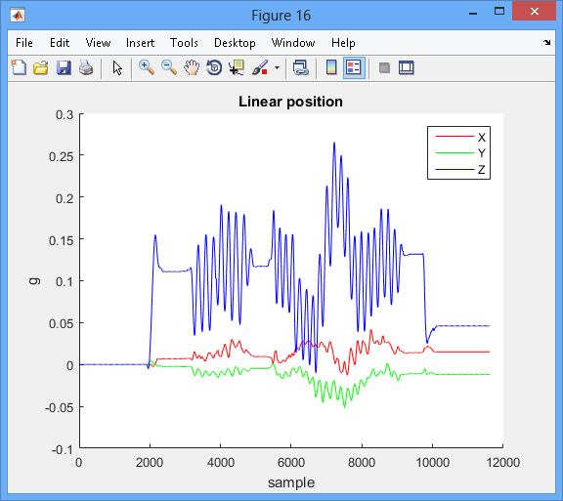

The graph should be what it is now, based on the video. It is because the object in the video is lifted to the air, shake and then placed it back to the table.

1. Dynamic high pass filtering

This is to suit more types of movement data and increase accuracy.

Velocity frequency spectrum in Y axis:

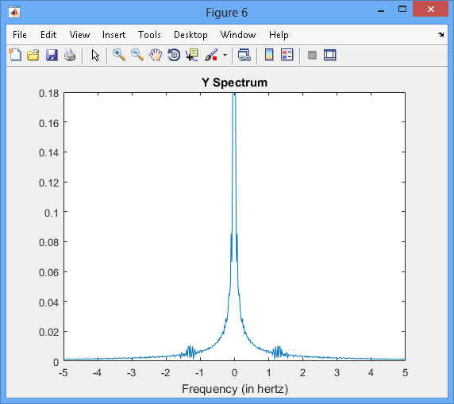

The area between the two red lines are harmful drifts and area out of the area is needed to calculate the real position.

Another example of Z axis:

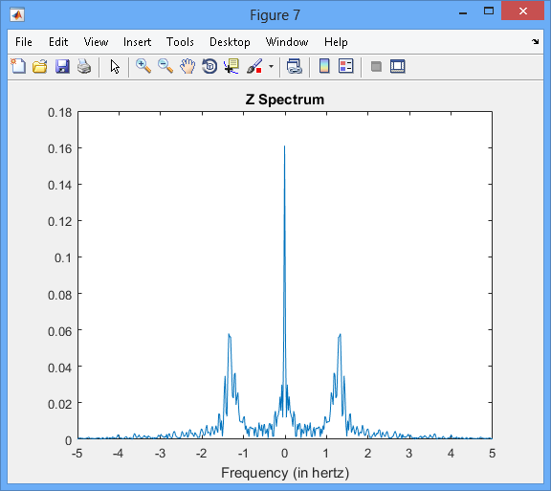

The task is to find where the red line is.

Actually, it is very tough to process such a non-stable graph so I use low pass filter to smooth the graph first.

Velocity frequency spectrum after low pass filter in Y axis:

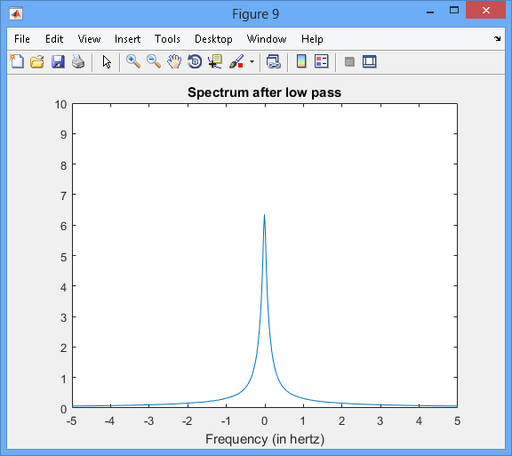

Velocity frequency spectrum after low pass filter in Z axis:

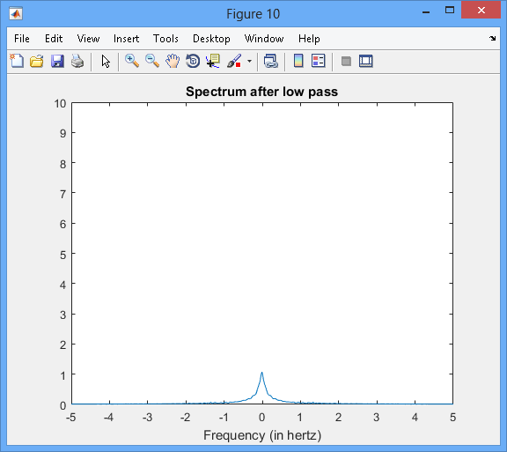

Now it is possible to process the graph and use program to determine the best cut off frequency.

1. Problems

Need a set of real device to continue on the real testing as the previous device stopped working. ☹

1. Plan for next Week
   1. I think I will discuss with Yao Quan and go to purchase a set of devices myself to continue on the project.
   2. Keep improving the filtering algorithm while waiting for the devices.
   3. Try to make use of the data from magnetometer to get a more reliable angle, as so far the current algorithm only uses 6 degrees data.